Complex Analysis Prelim — May 12, 1994

Instructions
Closed Book, 3 Hours, Do EIGHT of the ten problems.

Problems
- Let $f:C→C$ be analytic and satisfy
$$|f(z)|≤C(1+|z|)^{N}$$
- for some constant $C$ whenever $|z|≥R_{0}$. Give the general form for $f$ and prove that it is the general form.
- Let $f:C→C$ be analytic and satisfy
$$|f(z)|≤C(1+|z|)^{N}$$
- for some constant $C$ whenever $|z|≥R_{0}$. Give the general form for $f$ and prove that it is the general form.
  - Demonstrate the existence of some $ϵ>0$ so that
$$f(z)=\left\{\begin{matrix}z/(e^{z}-1), & z≠0 \\ 1, & z=0\end{matrix}\right.$$
  - is analytic in $N_{ϵ}(0)$.
  - Demonstrate rigorously that the radius of convergence of the power series for $f$ about $0$ is $2π$.
- Let
$$I(α)=\int_{0}^{∞}{\frac{z^{α}}{1+z^{2}}} dz$$
  - For which $α∈C$ does the integral make sense?
  - Calculate $I(α)$ using the path:
  - 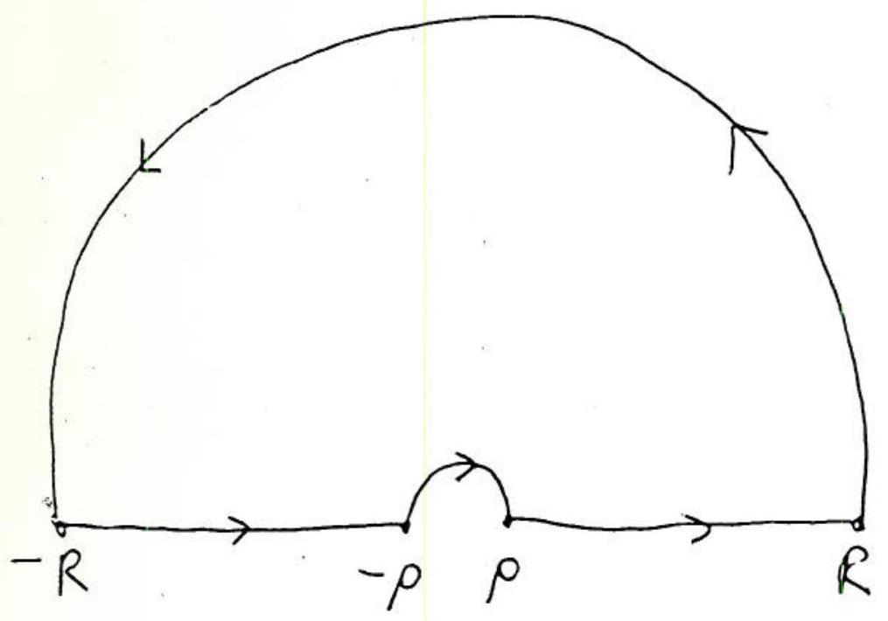
  - Contour for problem 3.
  - No change of variables is necessary.
- Let $U=\{z∈C; |z-z_{0}|<R, |z-z_{1}|>r_{1}, |z-z_{2}|>r_{2}\}$
- where $r_{1}+r_{2}<|z_{1}-z_{2}|, R-r_{1}>|z_{1}-z_{0}|, R-r_{2}>|z_{2}-z_{0}|$.
- 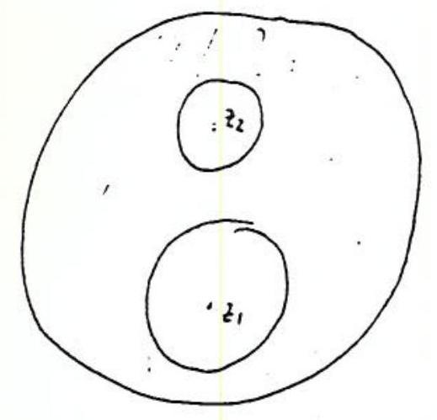
- Domain for problem 4.
- Let $f:U→C$ be analytic. Imitating the development in an annulus, show that
$$f(z)=\sum_{n=0}^{∞}{a_{n}}(z-z_{0})^{n}+\sum_{m=1}^{∞}{b_{-m}}(z-z_{1})^{-m}+\sum_{m=1}^{∞}{c_{-m}}(z-z_{2})^{-m}$$
- State and prove the analogue of Schwarz' lemma that holds under the hypotheses that $f:N_{1}(0)→N_{1}(0)$ is analytic and $f(0)=f^{'}(0)=0$.
- Let $α∈(0,2π]$ and let
$$\begin{aligned}U_{1}&=\{re^{iθ}; 0<r<1, 0<θ<α\} \\ U_{2}&=\{z∈C; |z|<1, Imz>0\} \\ U_{3}&=\{z∈C; Rez>0, Imz>0\} \\ U_{4}&=\{z∈C; Imz>0\} \\ U_{5}&=\{z∈C; |z|<1\}.\end{aligned}$$
- Find analytic bijections $U_{1}→U_{2}$, $U_{2}→U_{3}$, $U_{3}→U_{4}$, and $U_{4}→U_{5}$. (Powers and linear fractional transformations suffice.)
- Let $P(z)=z^{N}+a_{N-1}z^{N-1}+…+a_{0}$.
  - Use the change of variables $w=1/z$ to show that 12πi|z|=R​P'(z)P(z) dz=N for R sufficiently large.
  - Use the argument principle to draw a conclusion from (a).
- Use the function
$$\frac{1}{z^{2}sinz}$$
- to calculate $\sum_{n=1}^{∞}{(}-1)^{n}/n^{2}$.
- Let $f$ be a nonconstant doubly periodic meromorphic function on $C$. Show that $f$ must have at least two poles (counting multiplicity) in a fundamental domain (fundamental parallelogram.)
- Let $Λ$ and $Λ^{'}$ be two lattices in $C$. Let $f:C/Λ→C/Λ^{'}$ be an analytic map of Riemann surfaces. Show that the form of $f$ must be
$$f(z+Λ)=αz+β+Λ^{'}$$
- for some constants $α$ and $β$. (Use covering maps and problem 1.)

